CookieApp

Use-Case Specification: Login

Version 1.0

[Note: The following template is provided for use with the Rational Unified Process. Text enclosed in square brackets and displayed in blue italics (style=InfoBlue) is included to provide guidance to the author and should be deleted before publishing the document. A paragraph entered following this style will automatically be set to normal (style=Body Text).]

[To customize automatic fields in Microsoft Word (which display a gray background when selected), select File>Properties and replace the Title, Subject and Company fields with the appropriate information for this document. After closing the dialog, automatic fields may be updated throughout the document by selecting Edit>Select All (or Ctrl-A) and pressing F9, or simply click on the field and press F9. This must be done separately for Headers and Footers. Alt-F9 will toggle between displaying the field names and the field contents. See Word help for more information on working with fields.]

Revision History

|  |  |  |  |
| --- | --- | --- | --- |
| **Date** | **Version** | **Description** | **Author** |
| 16/10/14 | 1.0 | Initial Creation | Oliver |
|  |  |  |  |
|  |  |  |  |
|  |  |  |  |

Table of Contents

1. Login 4

1.1 Brief Description 4

2. Flow of Events 4

2.1 Basic Flow 4

3. Special Requirements 7

3.1 Database 7

4. Preconditions 7

4.1 Registered user 7

5. Postconditions 7

5.1 Logged in 7

1. Login
   1. Brief Description

The user logs in to be able to access functions, that need identification.

1. Flow of Events
   1. Basic Flow

The user enters his credentials (name and password) and confirms by clicking a button or pressing the  
 'enter' key.

The system checks the combination of name and password.

If the combination exists in the database, the system grants access to the restricted areas.

If the check fails, the user will get an error.

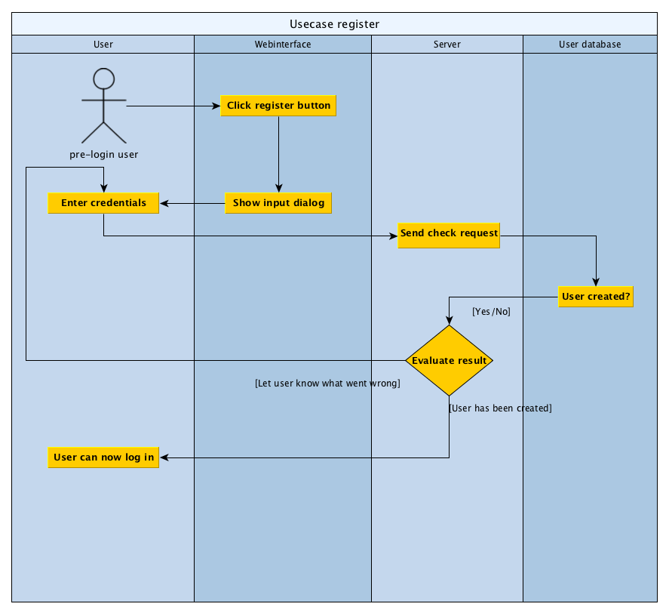



1. Special Requirements
   1. Database

The system needs a database to connect to and compare the combination of name and password that the

user entered to the ones that are registered.

1. Preconditions
   1. Registered user

The user has to be registered with the same combination of name and password.

1. Postconditions
   1. Logged in

The user will be logged in.